ENGINEER OS · Computer Organization & Architecture
03. Stack & Heap Deep Dive
Difficulty | Reading Time | Prerequisites | Outcome
⭐⭐ Intermediate | 10–12 min | Chapters 01–02 | Explain push/pop, stack frames, heap allocation & GC — with confidence

Story
Waiter's Notepad vs Storage Warehouse
The Stack is a waiter's order spike — notes clipped on top, always removed from the top first (LIFO). The Heap is a self-storage warehouse — rent any size unit, keep it as long as you want, but you must remember to check out.

Visual Imagination
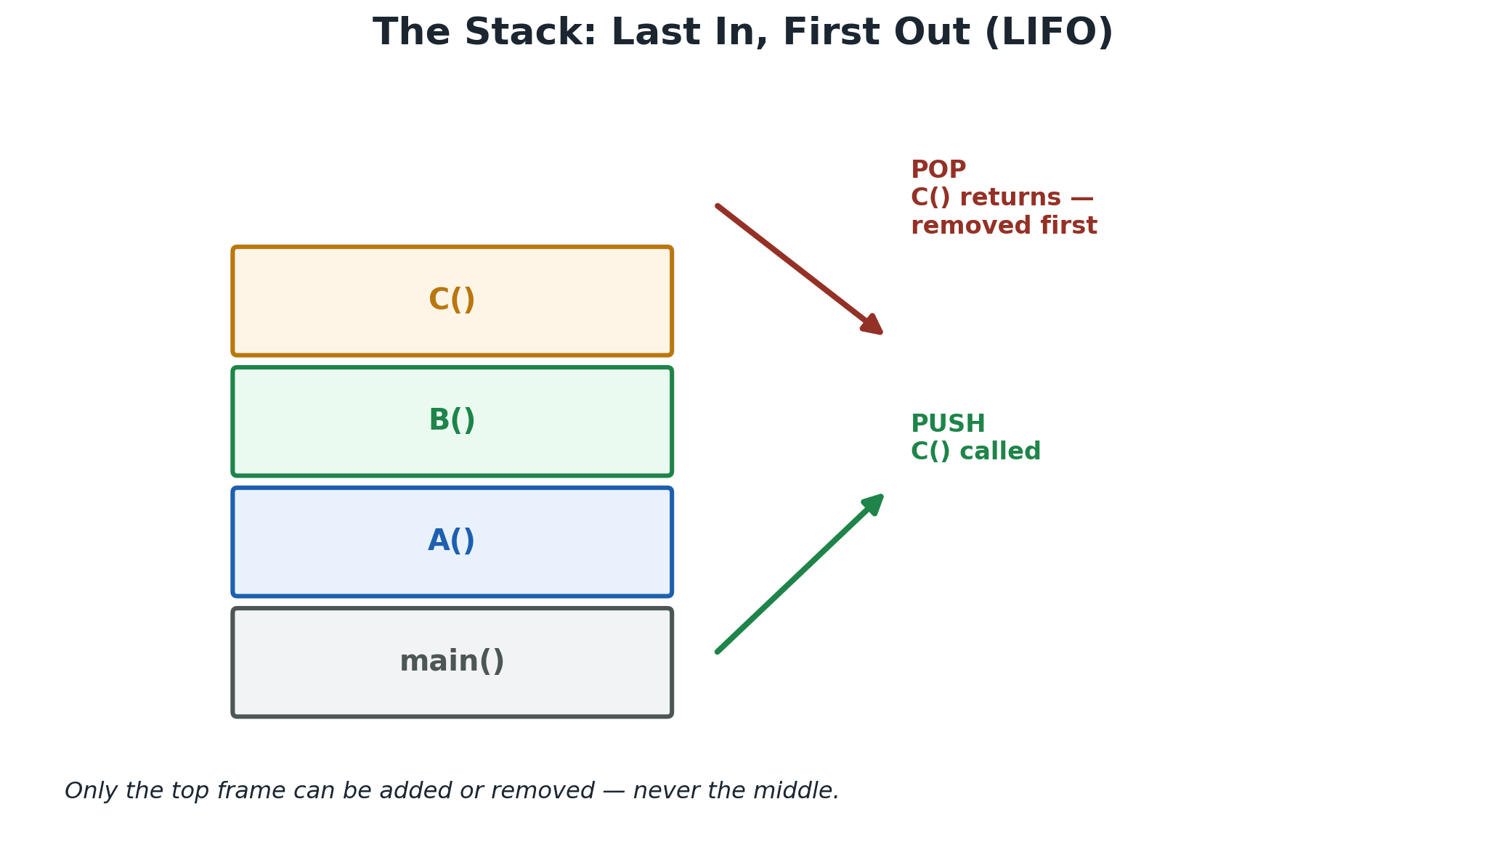 | 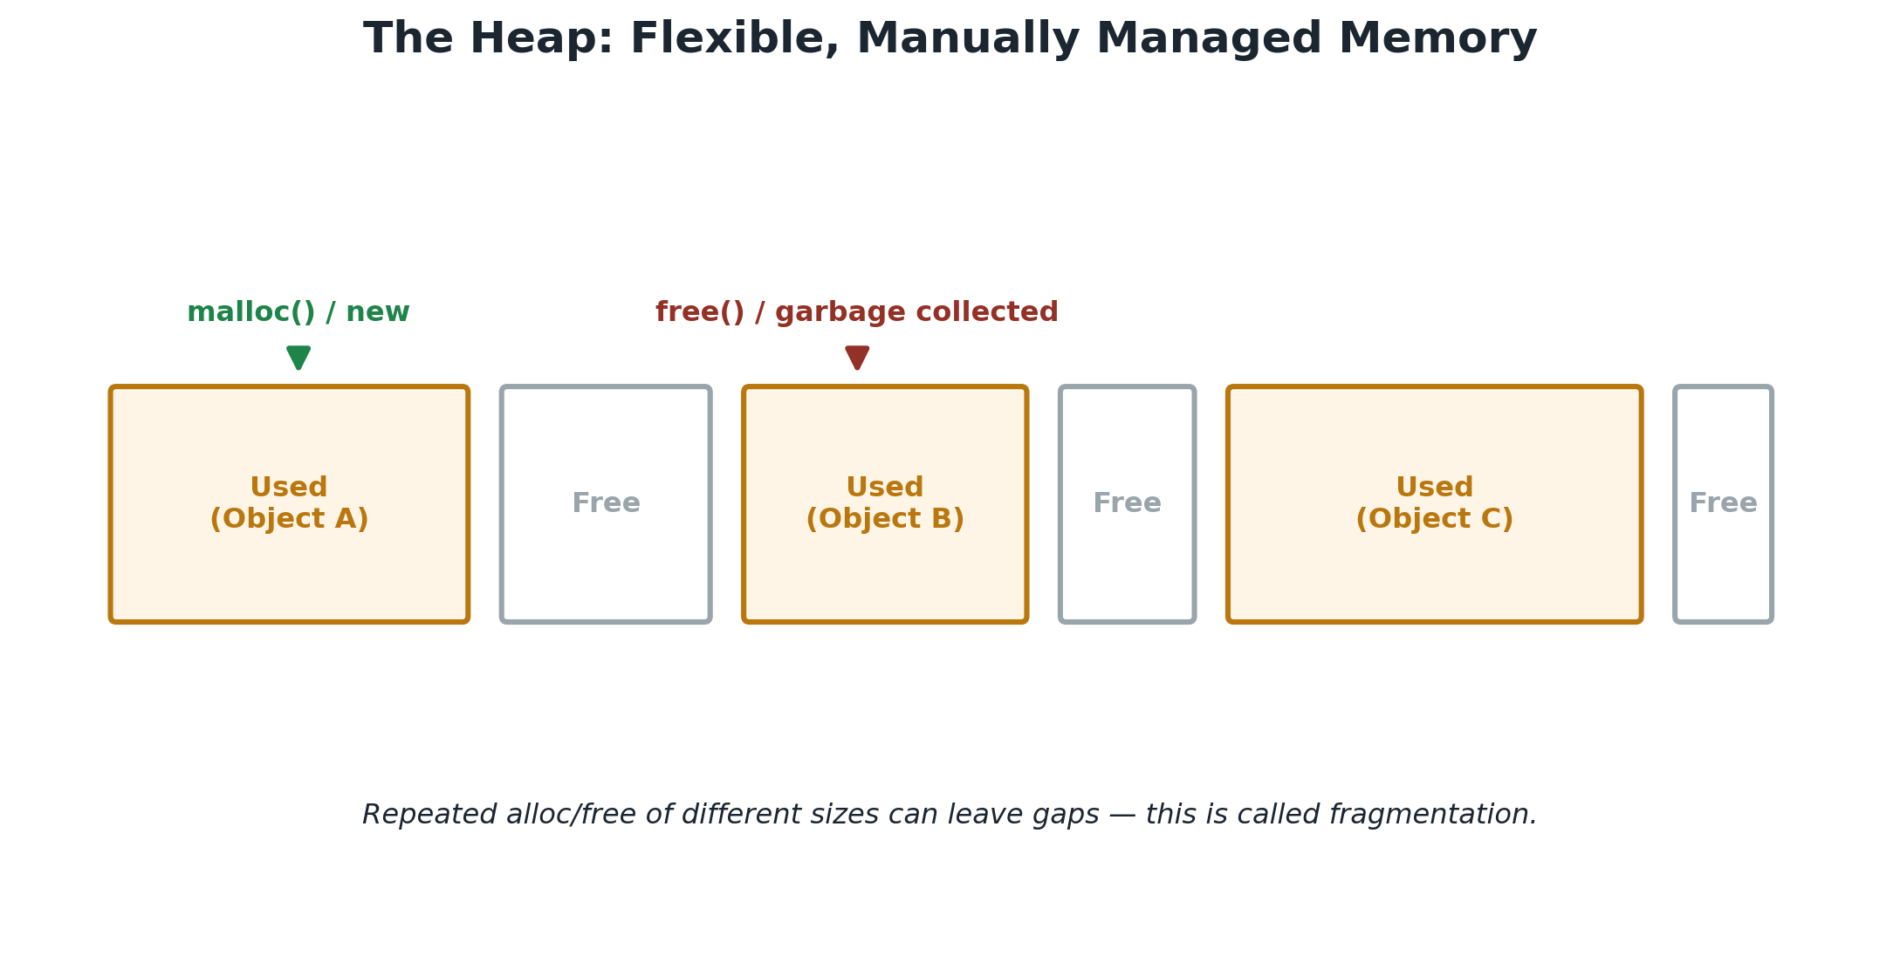
ELI5 + First Principles
Toy Box vs Building Blocks
Stack = toys you use for one game, put away automatically when done. Heap = building blocks you keep out as long as you like — but YOU have to put them away. The stack exists because the CPU needs an ultra-fast, disciplined place for short-lived data; the heap exists because some data must be flexible in size and outlive a single function call.

Inside a Stack Frame
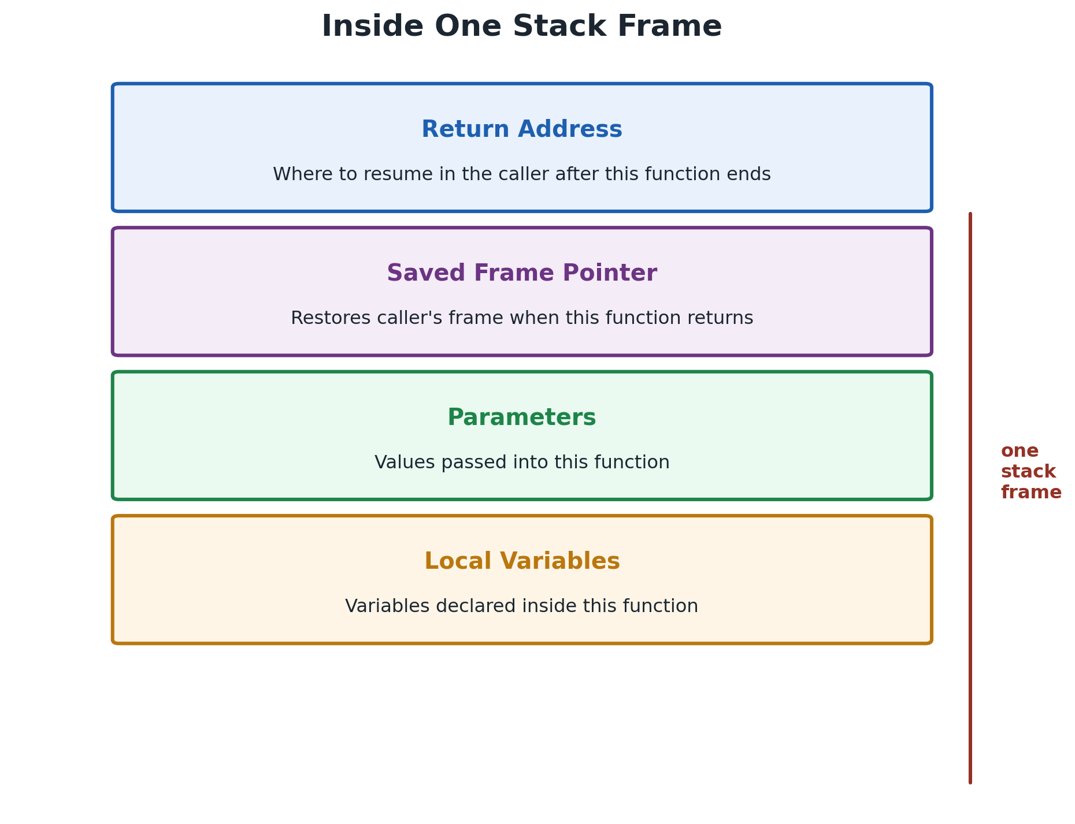 | Return Address — where to resume in the caller.  Saved Frame Pointer — restores caller's context.  Parameters — values passed into the call.  Local Variables — exist only for this call.

Recursion & Stack Overflow
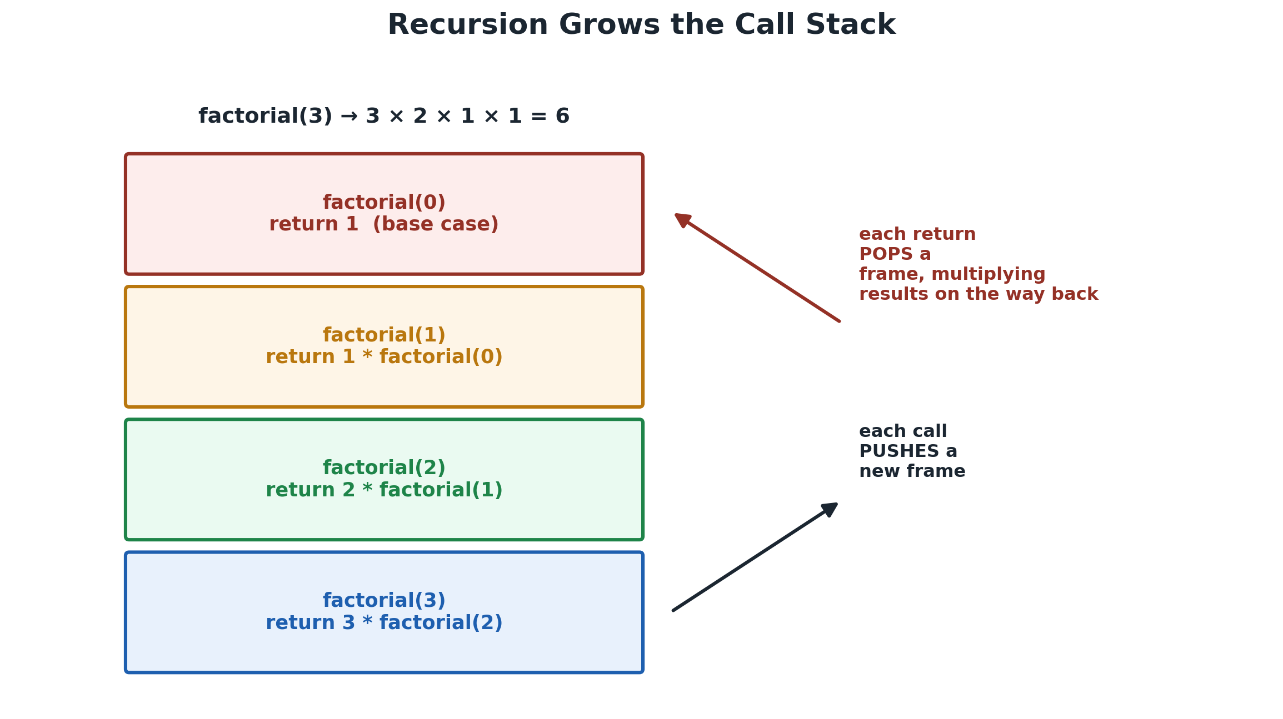 | 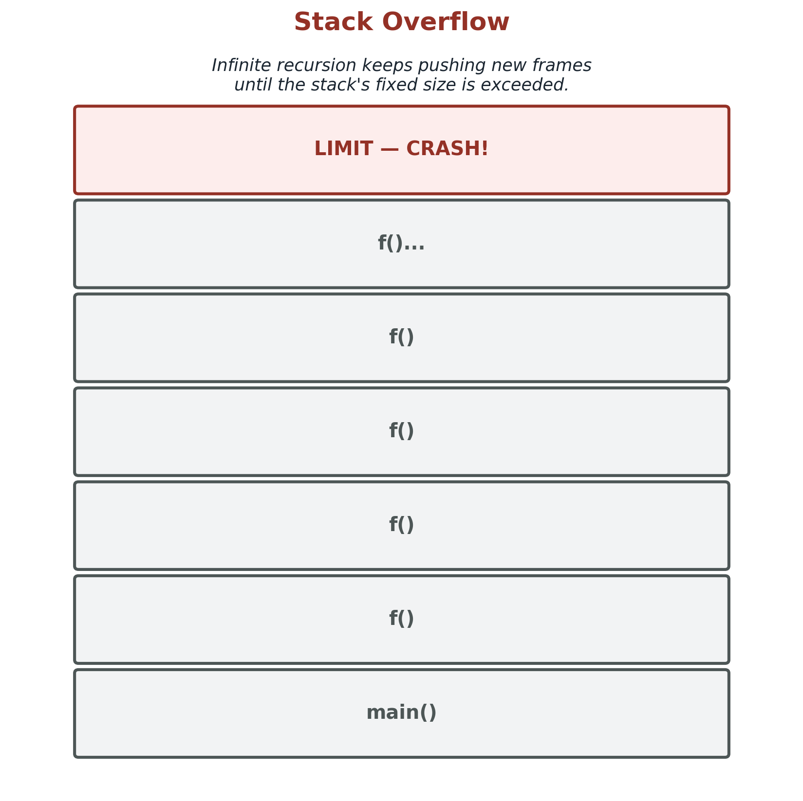
Each recursive call PUSHES a frame; unwinding POPS them. Infinite/too-deep recursion exceeds the stack's fixed size → crash.
Heap: Allocation, Fragmentation & GC
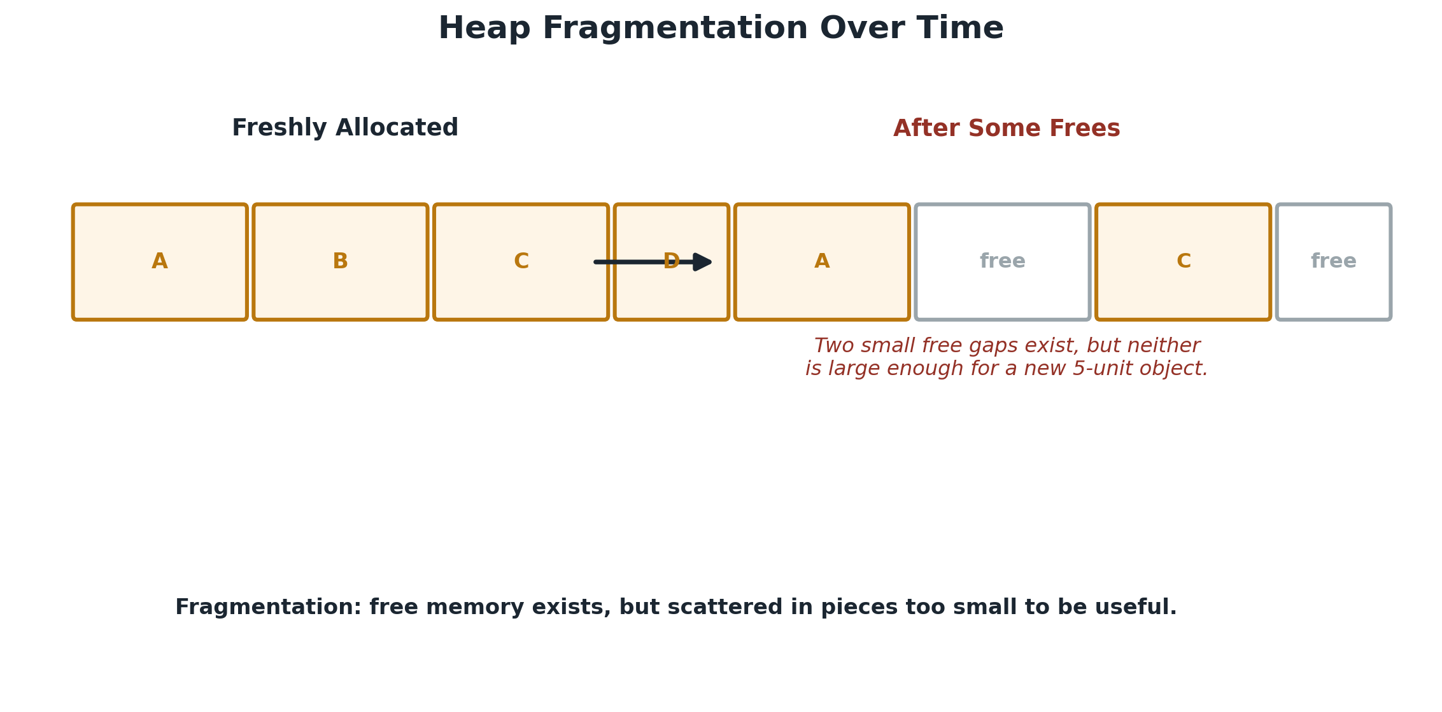 | 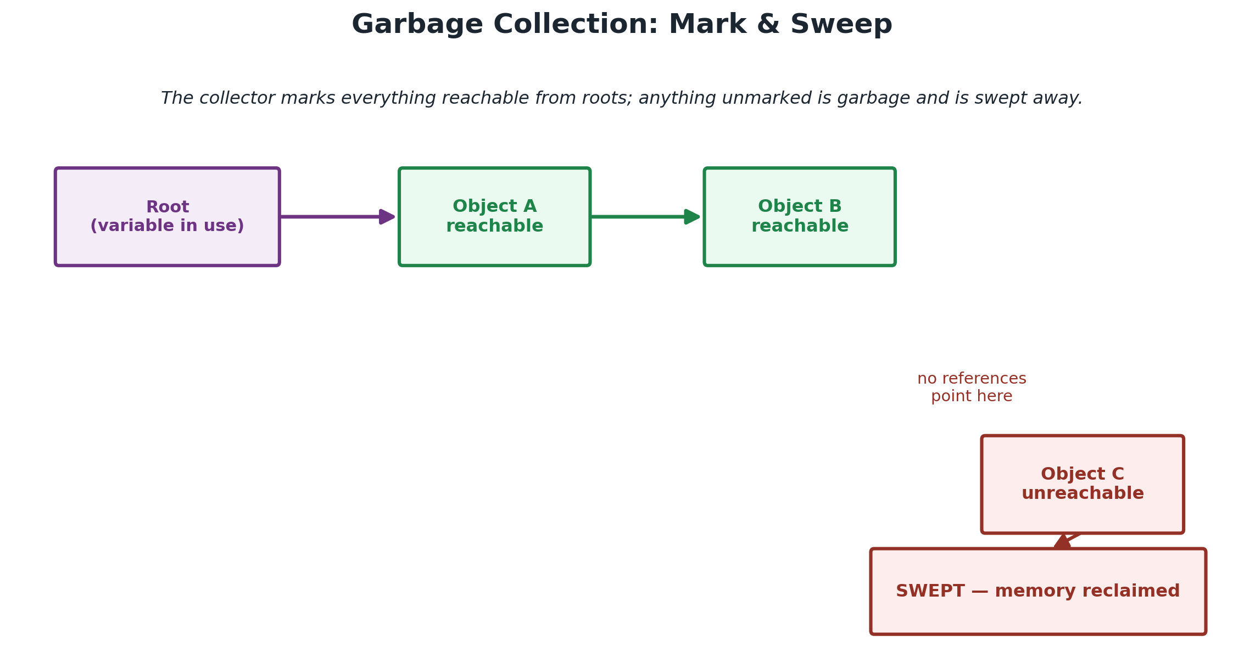
Allocation searches a free list (slower than the stack); freed gaps can fragment. Garbage collectors mark reachable objects and sweep the rest — removing manual free() bugs at the cost of possible pauses.

The Full Execution Flow
This single flow connects everything in the chapter — every PUSH going down is a call; every POP coming back up is a return.
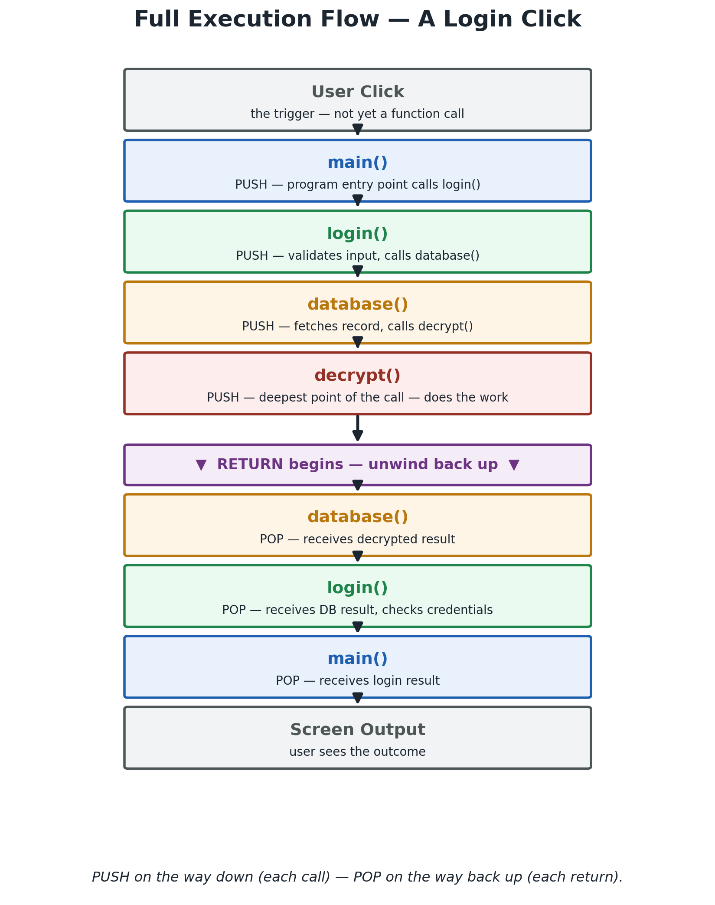

Stack Evolution — Watching It Grow
The same login() call from the previous page, frame by frame — then unwinding.
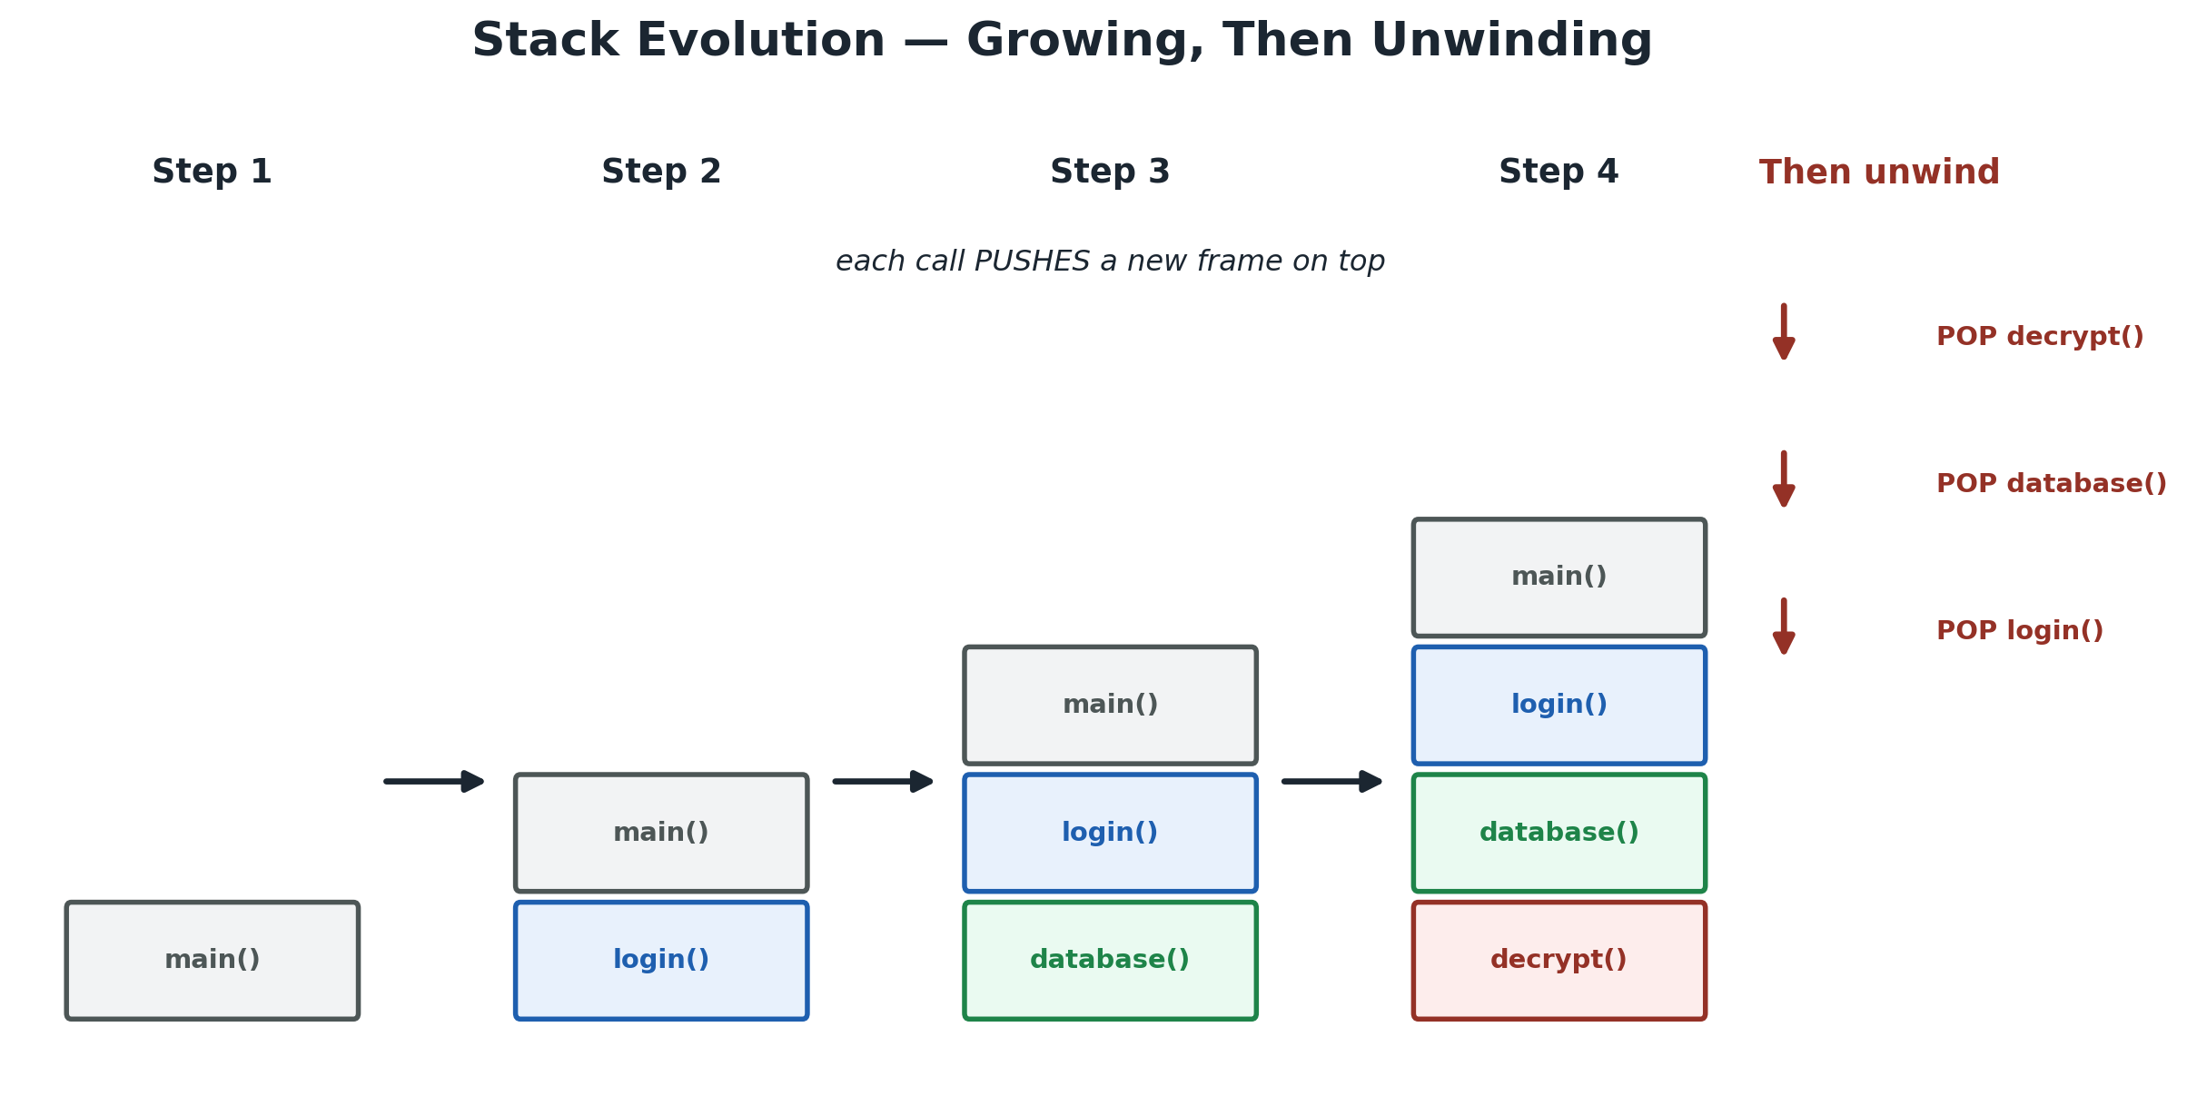

Memory Layout — Back to Chapter 02
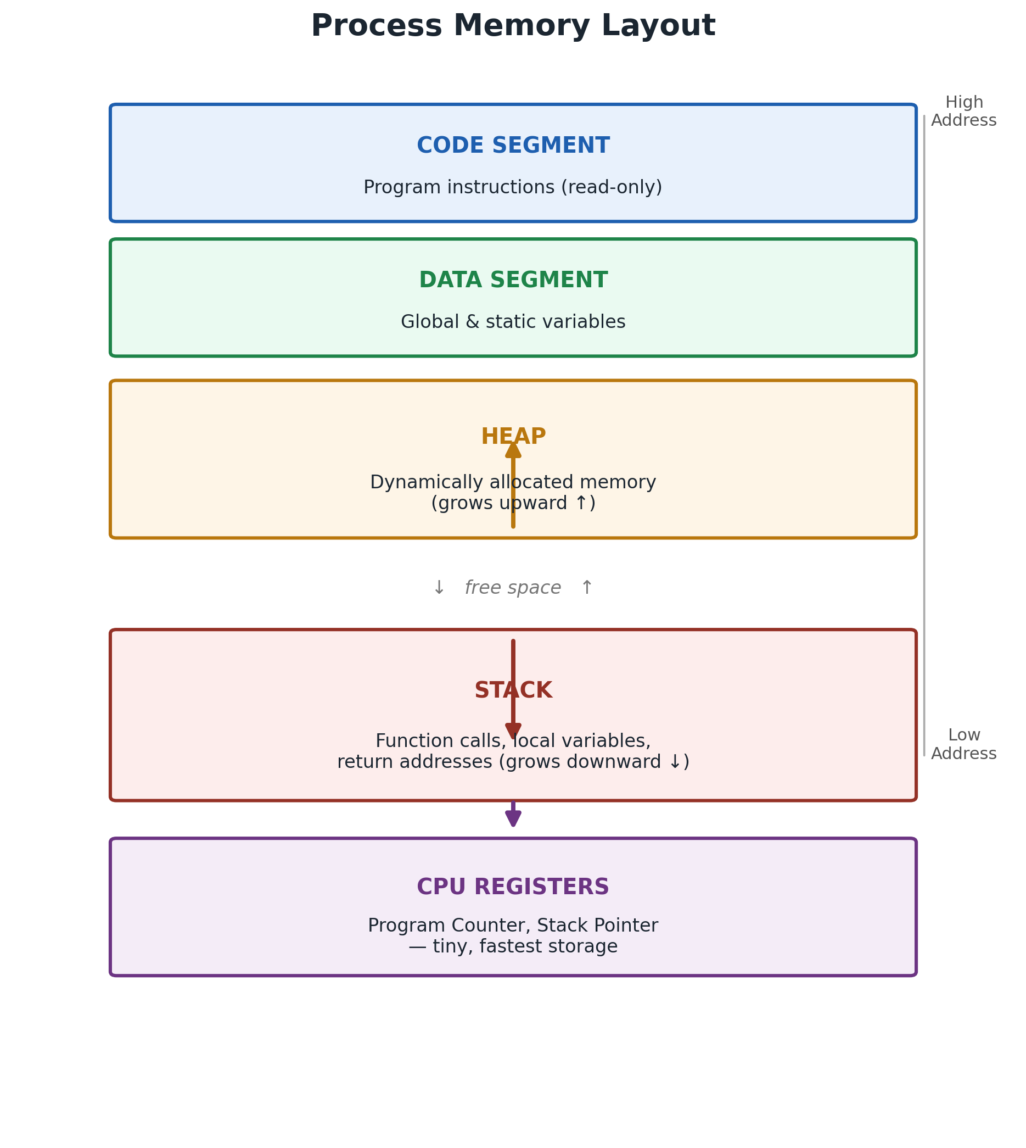 | This chapter's Stack and Heap are the same two regions from Chapter 02's memory layout — now you've seen exactly what moves through them, call by call.  Stack grows downward from high addresses; Heap grows upward from low addresses — toward each other, in the same shared space.

Where Is This Used?
The exact Stack/Heap mechanics from this chapter run inside systems you already use every day.
System | How Stack / Heap Shows Up
Chrome | Every nested JS function call uses the stack; every JS object you create lives on the heap.
ChatGPT | Model weights and tensors — far too large and long-lived for the stack — live on the heap (GPU memory).
Linux / Windows | Each thread gets its own fixed-size stack; the kernel's own allocators manage heap-like memory.
Games | Engines avoid heap allocation mid-frame — tight time budgets favor the stack or pre-allocated pools.
Databases | Query execution uses the stack for nested operations; row/index data is heap-allocated at scale.
AI Systems | Training and inference allocate huge heap buffers for activations, gradients, and weights.
Cloud Computing | Every request handler's local state lives on a stack frame inside its container or VM.
Compilers | Generate the very push/pop instructions that build each stack frame you saw on the previous pages.

Stack vs Heap
Aspect | Stack | Heap
Alloc cost | ~1 instruction (pointer move) | Search + bookkeeping — slower
Size | Small, fixed per thread | Large, flexible
Lifetime | Ends when function returns | Until freed / collected
Managed by | CPU / compiler, automatic | Programmer or GC
Common failure | Stack Overflow | Memory Leak / fragmentation

Common Mistakes
✗ Mistake | ✓ Reality
Returning a pointer to a local variable is safe. | Its frame is popped on return — that memory is invalid.
Heap memory frees itself when I'm done. | It needs free() or a garbage collector, or it leaks.
Garbage collection makes leaks impossible. | An unintentionally-kept reference still prevents collection.

Interview Corner — Top 5
Q. Why is the stack faster than the heap?
A. Stack alloc is a pointer move; heap alloc requires searching a free list and bookkeeping.
Q. What causes a Stack Overflow?
A. Too many nested calls (often unbounded recursion) exceeding the stack's fixed size.
Q. What is a memory leak?
A. Heap memory that becomes unreachable but is never freed.
Q. What is fragmentation?
A. Free memory scattered in pieces too small to satisfy new requests.
Q. What does Mark & Sweep do?
A. Marks all reachable objects from roots, then reclaims everything left unmarked.
Quick Revision & Golden Rule
Remember
Stack = LIFO, fast, automatic, fixed-size, short-lived. Heap = flexible, slower, manual/GC-managed, long-lived.

Golden Rule
The Stack trades flexibility for speed. The Heap trades speed for flexibility — and hands you the cleanup bill.

Flashcards
Q: What does LIFO mean?  A: Last In, First Out.  Q: What triggers a stack POP?  A: A function return. | Q: Who manages heap allocation?  A: The Heap Manager (runtime/OS).  Q: What usually causes a leak?  A: A lost reference to still-allocated memory.

Mini Quiz
1. The stack follows: (a) FIFO (b) LIFO (c) Random
2. Heap allocation is generally: (a) Faster than stack (b) Slower than stack (c) Identical speed
3. Garbage collection reclaims memory using: (a) Push/Pop (b) Mark & Sweep (c) Fetch/Decode
Next Chapter → What Is a CPU?
Coming Up
We've covered where data lives. Next: registers, the ALU, the control unit, and how Fetch-Decode-Execute cycles bring stack and heap to life.

“
The Stack optimizes execution.
The Heap optimizes flexibility.
Modern software needs both.
— Engineer OS

